RAISE YOUR VOICES CHOIR, WELCOME NOTES August 2025


We are delighted to learn that you would like to come along to choir and we hope these notes will give you an idea of what to expect:

Raise Your Voices is a mixed voice community choir based in Wirksworth. It was formed in 2009, purely for the joy of singing, under the direction of Lester Simpson, singer, songwriter and musician, also a member of the renowned a cappella folk trio, Coope, Boyes and Simpson for almost 25 years…

Everyone who wants to sing together in harmony is welcome, from novices to the more experienced singers. There are no auditions, and it is not necessary to be able to read music, as although most of the songs are issued with the scores so you can ‘follow the dots’, some are simply taught by ear…

RYV sings great songs, a cappella, in three or four parts. We learn a wide range of styles from many different genres, from folk to modern, from sea shanties to traditional songs, from Bob Dylan to Sibelius, from all around the world and arranged especially for us by our Musical Director Lester Simpson.

We raise funds for local charities from concerts, host workshops led by visiting tutors and generally have a jolly good time with several additional social events throughout the year and a brilliant bunch of people who all just love to sing …

Over the years we have performed at many interesting places and events in the area, such as the National Stone Centre, Repton School, and at several Wirksworth festivals. In 2016 we featured in the BBC’s double BAFTA award winning film “Marvellous” about Neil Baldwin, aka “Nello the Clown” and of Stoke City Football Club fame…what a great experience that was!
You can see photos of our exploits on the RYV website.

- Venue – Wellspring – corner of St Johns Steet and Wood Street
First floor main room – access via stairs and lift. The temperature is comfortable as is the seating!
On hot summer evenings we sometimes move down to the cooler but rather reverberative basement or are on holiday most of August.
- Time - 7pm-9pm most Thursday evenings
(Note the times – people may arrive from 6.45 to pay subs, settle in and mingle.)
- Subs - £5 weekly on a Pay as you Go basis. Cash or card payment accepted.
If cash, please try to have the correct money. Thank you.
- Registration
Our treasurer Pam Daws or another member of ‘Steerage’ usually takes the subs and checks in attendees on the register at the door. This is also used as a name check in the event of fire. Please do therefore make sure you are signed in on entry.
- Voice parts – (Soprano, Alto, Tenor or Bass)
If you don’t know which part you sing, start in the section you think might suit, and if you feel something lower or higher would suit your voice better, simply move to another, even if only for certain songs.
- Music
The list of songs Lester selects weekly is sent out a couple of days before each session for singers to print off personal copies. Music is not issued at the sessions although if you have no printing facilities, please let us know and we will try to find you a printing buddy who can do this for you.
- Seating
This is usually already set out for each voice section before you arrive but we may ask for help to move them into place if the room has been used just before us, then return them to where they were afterwards. Please respect the spacing arrangements and do not move chairs too close to other singers as we do all need room to breathe and keep our music and belongings handy.
Cont…

Cont…..

- Parking
Spaces can be limited in town, but there are roadside spaces after 6 pm and also in the free car park behind The Wheatsheaf pub, or further into town in the Market Car Park by the Hope and Anchor
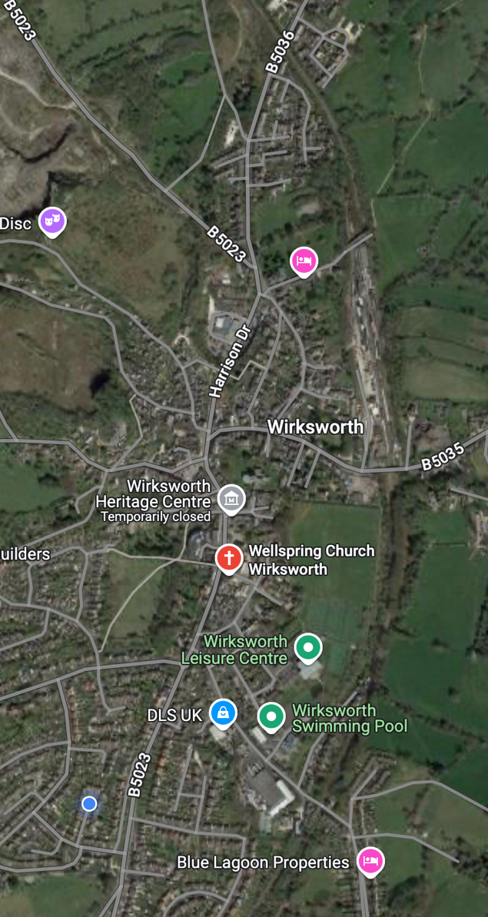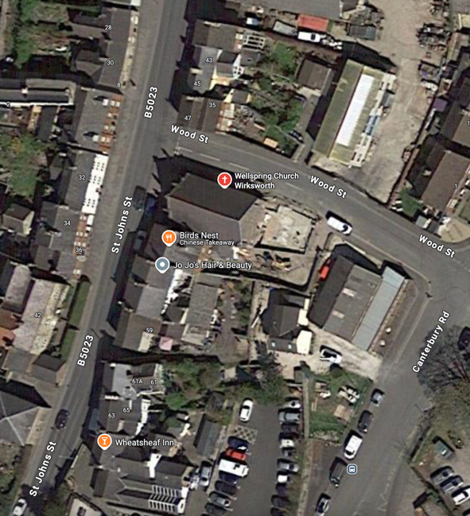

We look forward to meeting you soon. NB All points are subject to review and change at regular intervals.

Please also find the GDPR form for you to print, complete and return, electronically if you can, or if not, just send the info that is requested in an email, but there’s no hurry before you’ve decided if you like us!
If you don’t want to come again, forget the form!

If you have friends interested in singing with us, please do pass this on to them to explain what to expect.

So, before you come along for the first time simply request the songs for the week by email to print out and bring with you. You will gradually build up your portfolio after the first week with rather a lot!

And finally, it’s a good idea to bring a bottle of water to wet your whistle and a pencil to mark your scores with any notes Lester might give us….

Rusty Ahearne
RYV Steering Group Co-ordinator for Communications, Social Media and PR, and on behalf of Lester Simpson, Musical Director, and the RYV Steering Group members: Treasurer Pam Daws, Peter Chivers, Marilyn Hambly, Ranald Macdonald, Sue Millward and John Wheeldon.

website: https://www.raiseyourvoicesww.com Facebook @RYVWirksworth email raiseyourvoiceswirksworth@gmail.com

